1. **Acceptance Criteria :**

Feature 1:

1. Service charge for each merchant bill payment is 1% of the customer’s balance.
2. The minimum service charge for any transaction is 5 TK.
3. Customers will get 10% cashback, if they made a transaction of more than 5000 TK.
4. Customers will get 20% cashback, if they made a transaction of more than 10000 TK and they will receive a maximum cashback amount of 3000 TK.
5. Customers won’t get cashback for utility bills.
6. Ensure that the minimum service charge is 5 TK not less than that.
7. Calculate the cashback policy carefully and only apply the rules based on requirements.

Feature 2:

1. For applying the loan, customers should have an amount of less than 100 TK.
2. Customers can apply for a loan up to 20000 TK.
3. No interest will be charged if customers repays the loan within 30 days from the loan initiation days.
4. A daily interest of 1.8% will be applied in a compound interest manner on the remaining amount, if the customers fail to repay within the mentioned time.
5. After paying 50% of the current loan a customer can be eligible for another new loan.

**2. Priority Sequence:**

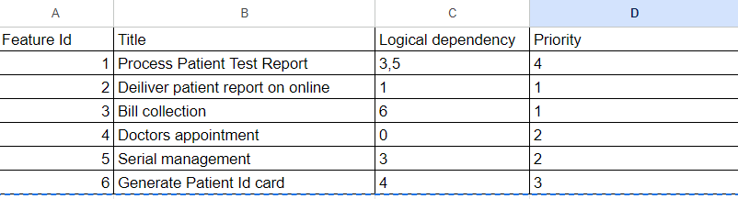

4> 6> 3> 5> 1> 2

First, the user has to take **doctor's appointment,** then the system will **generate Patient Id card** and the next step is **“bill collection”.** After that, the user will get a serial by the “**serial management**” step. System will **process patient test report** and finally **deliver patient report on online**.

**3. Checklist based on test case**

| Serial | CheckPoint | Yes | No |
| --- | --- | --- | --- |
| **1** | Can customers pay merchant or utility bills? | Y |  |
| **2** | Will 1% service charge be deducted for merchant bill payment from the customer's balance? | Y |  |
| **3** | Is the minimum transaction fee 5tk? | Y |  |
| **4** | Will customers get 10% cash-back for transactions of more than 5000 TK? | Y |  |
| **5** | Will customers get 20% cash-back for transactions totaling over 10000 TK? | Y |  |
| **6** | Will the customer get the maximum amount being 3000 tk? | Y |  |
| **7** | Can customer payment with  insufficient balance? |  | N |
| **8** | Can customer make a payment with  characters in integer field? | Y |  |
| **9** | Is the loan application of a customer applicable when the balance is 100 tk or more than that? |  | N |
| **10** | Will interest be added to the loan, if the customer repays within 30d? |  | N |
| **11** | Should 1.8% interest be applied to the amount of the loan? | Y |  |
| **12** | Can customer get the next loan with less than 50% payment? | Y |  |
| **13** | Can customer get another loan without paying existing loan |  | N |